Graphing Exponential and Logarithmic Functions
Graph each function.
- $f(x)=4⋅2^{x}$
- 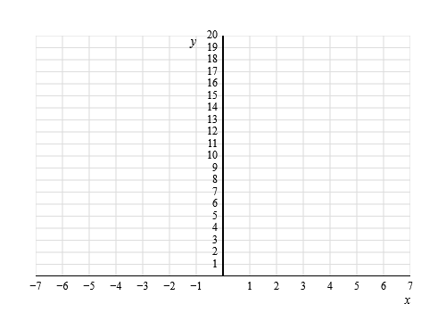
- $g(x)=5⋅2^{-x}$
- $f(x)=4{\left(\frac{1}{2}\right)}^{x-1}-2$
- 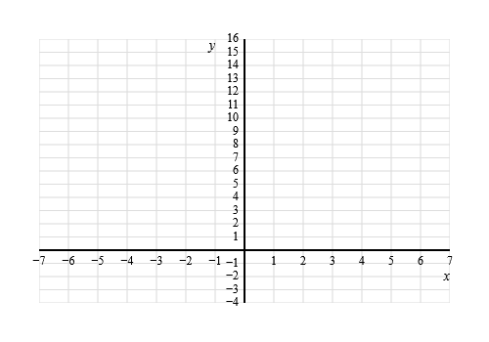
- $g(x)=3⋅2^{x-2}+2$
- $f(x)=\log_{2}(x)$
- 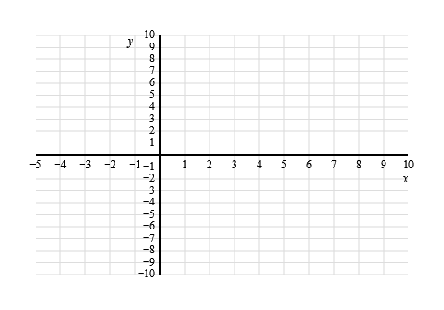
- $g(x)=5+\log_{2}(x-3)$

Graphing Exponential and Logarithmic Functions: Answer Key
- $f(x)=4⋅2^{x}$
- 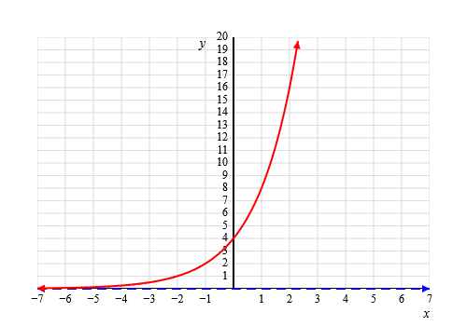
- $g(x)=5⋅2^{-x}$
- 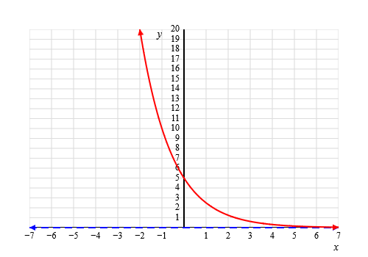
- $f(x)=4{\left(\frac{1}{2}\right)}^{x-1}-2$
- 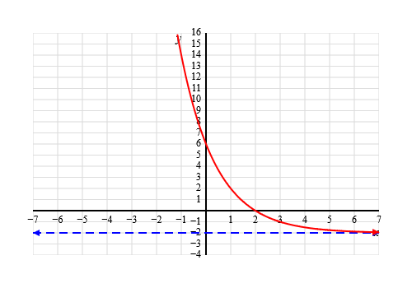
- $g(x)=3⋅2^{x-2}+2$
- 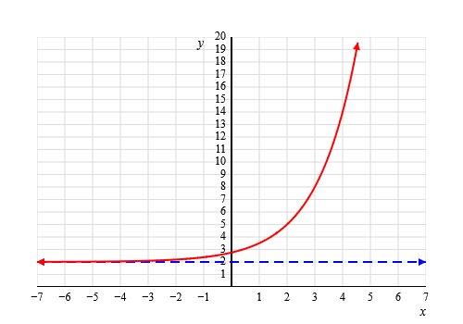
- $f(x)=\log_{2}(x)$
- 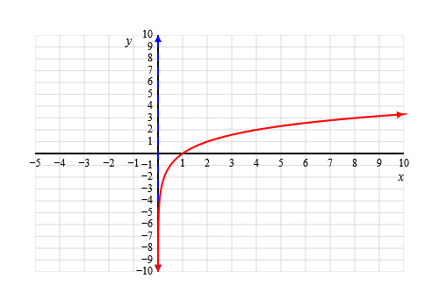
- $g(x)=5+\log_{2}(x-3)$
- 