Absolute Value Inequalities
Solve each inequality and graph its solution.
- $\left|6n\right| ≤18$
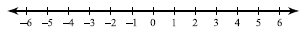
- $|p+4|≤8$
- $\left|m-2\right|<8$
- $\left|5x\right|≤10$
- $\left|x\right|+5≥11$
- $\left|m\right|-2>0$
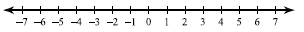

- $\left|r\right|-3>2$
- $\left|n\right|+2≥5$
- $\left|x-2\right|-5<-2$
- $\left|x-4\right|-3<5$
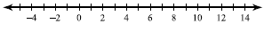
- $1+\left|1+b\right|<4$
- $\left|v+5\right|-6<-5$
- $\left|10p-4\right|<34$

- $\left|6+9x\right|≤24$
- $\left|-8a-3\right|>11$
- $|1-4k|≥-11$
- $9\left|m-8\right|-10<26$
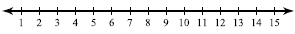
- $9\left|x+8\right|+10<55$
- $9\left|r-2\right|-10<-73$
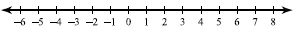
- $7\left|\frac{n}{3}\right|-9<12$
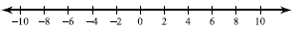
- $2\left|10b+7\right|-1>73$
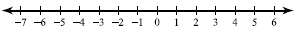
- $7+\left|6v+7\right|≤60$
- $4\left|6-2a\right|+8≤24$
- $9\left|3n-2\right|+6>51$
- $3+4\left|3x+7\right|≥-89$
- $9\left|1+8n\right|-3≥78$

Absolute Value Inequalities: Answer Key
- $\left|6n\right| ≤18$
Answer: Number line: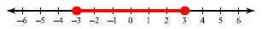
Inequality: $-3≤n≤3$ Interval notation: $\left[-3,3\right]$
- $|p+4|≤8$
Answer: Number line:
Inequality: $-12≤p≤4$ Interval notation: $[-12,4]$
- $\left|m-2\right|<8$
Answer: Number line: 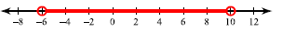
Inequality: $-6<m<10$ Interval notation: $\left(-6,10\right)$
- $\left|5x\right|≤10$
Answer: Number line:
Inequality: $-2≤x≤2$ Interval notation: $[-2,2]$
- $\left|x\right|+5≥11$
Answer: Number line:
Inequality: $x≥6$or $x≤-6$ Interval notation: $\left(-∞,-6\right]∪\left[6,∞\right)$
- $\left|m\right|-2>0$
Answer: Number line:
Inequality: $m>2$ or $m<-2$ Interval notation: $\left(-∞,-2\right)∪\left(2,∞\right)$

- $\left|r\right|-3>2$
Answer: Number line: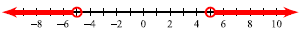
Inequality: $r>5$ or $r<-5$ Interval notation: $\left(-∞,-5\right)∪\left(5,∞\right)$
- $\left|n\right|+2≥5$
Answer: Number line:
Inequality: $n≥3$ or $n≤-3$ Interval: $\left(-∞,-3\right]∪\left[3,∞\right)$
- $\left|x-2\right|-5<-2$
Answer: Number line:
Inequality: $-1<x<5$ Interval notation: $\left(-1,5\right)$
- $\left|x-4\right|-3<5$
Answer: Number line:
Inequality: $-4<x<12$ Interval notation: $\left(-4,12\right)$
- $1+\left|1+b\right|<4$
Answer: Number line:
Inequality: $-4<b<2$ Interval notation: $\left(-4,2\right)$
- $\left|v+5\right|-6<-5$
Answer: Number line:
Inequality: $-6<v<-4$ Interval notation: $\left(-6,-4\right)$
- $\left|10p-4\right|<34$
Answer: Number line:
Inequality: $-3<p<\frac{19}{5}$ Interval notation: $\left(-3,\frac{19}{5}\right)$
- $\left|6+9x\right|≤24$
Answer: Number line:
Inequality: $-\frac{10}{3}≤x≤2$ Interval notation: $\left[-\frac{10}{3},2\right]$
- $\left|-8a-3\right|>11$
Answer: Number line:
Inequality: $a<-\frac{7}{4}$ or $a > 1$ Interval notation: $\left(-∞,-\frac{7}{4}\right)∪\left(1,∞\right)$
- $|1-4k|≥-11$
Answer: Number line: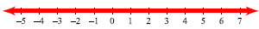
All real numbers Interval notation: $\left(-∞,∞\right)$
- $9\left|m-8\right|-10<26$
Answer: Number line:
Inequality: $4<m<12$ Interval notation: $\left(4,12\right)$
- $9\left|x+8\right|+10<55$
Answer: Number line:
Inequality: $-13<x<-3$ Interval notation: $\left(-13,-3\right)$
- $9\left|r-2\right|-10<-73$
Answer: Number line: No solution.
- $7\left|\frac{n}{3}\right|-9<12$
Answer: Number line:
Inequality: $-9<n<9$ Interval notation: $\left(-9,9\right)$
- $2\left|10b+7\right|-1>73$
Answer: Number line:
Inequality: $b>3$ or $b<-\frac{22}{5}$ Interval notation: $\left(-∞,-\frac{22}{5}\right)∪\left(3,∞\right)$
- $7+\left|6v+7\right|≤60$
Answer: Number line:
Inequality: $-10≤v≤\frac{23}{3}$ Interval notation: $\left[-10,\frac{23}{3}\right]$
- $4\left|6-2a\right|+8≤24$
Answer: Number line:
Inequality: $1≤a≤5$ Interval notation: $\left[1,5\right]$
- $9\left|3n-2\right|+6>51$
Answer: Number line:
Inequality: $n>\frac{7}{3}$ or $n<-1$ Interval notation: $\left(-∞,-1\right)∪\left(\frac{7}{3},∞\right)$
- $3+4\left|3x+7\right|≥-89$
Answer: Number line:
All real numbers Interval notation:$\left(-∞,∞\right)$
- $9\left|1+8n\right|-3≥78$
Answer: Number line: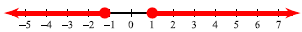
Inequality: $n≥1$ or $n≤-\frac{5}{4}$ Interval notation: $\left(-∞,-\frac{5}{4}\right]∪\left[1,∞\right)$

