Written Feedback Tutorial for Students

- On your Navigate 360 homepage, click “Appointments”
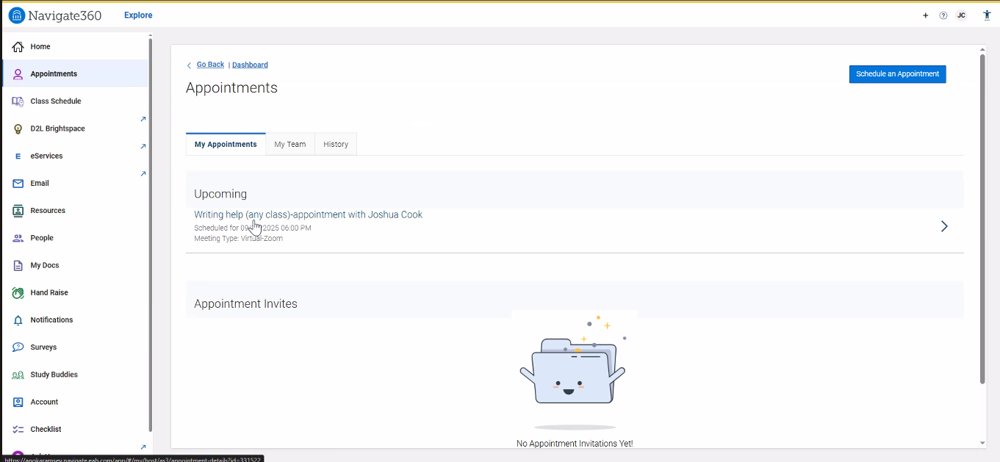

- Click “Schedule an Appointment”

- From the two dropdown menus, select “Tutoring” and “Writing Help (any class)-written feedback”
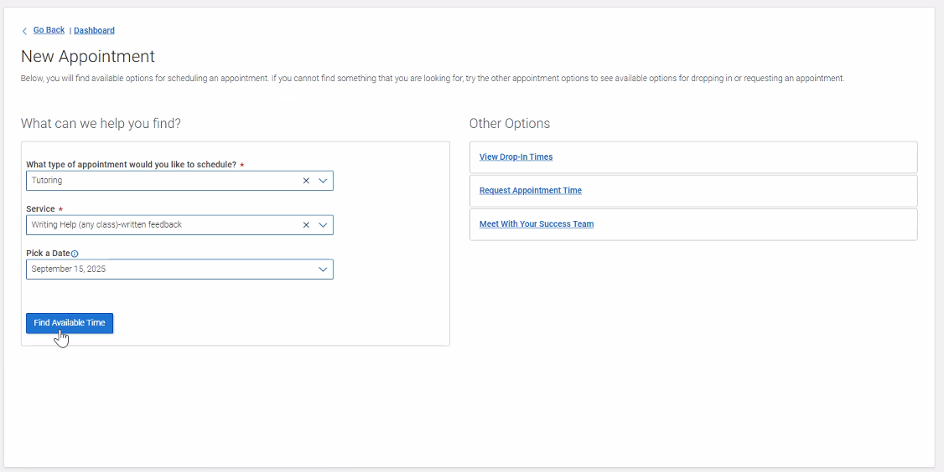

- Select your desired date
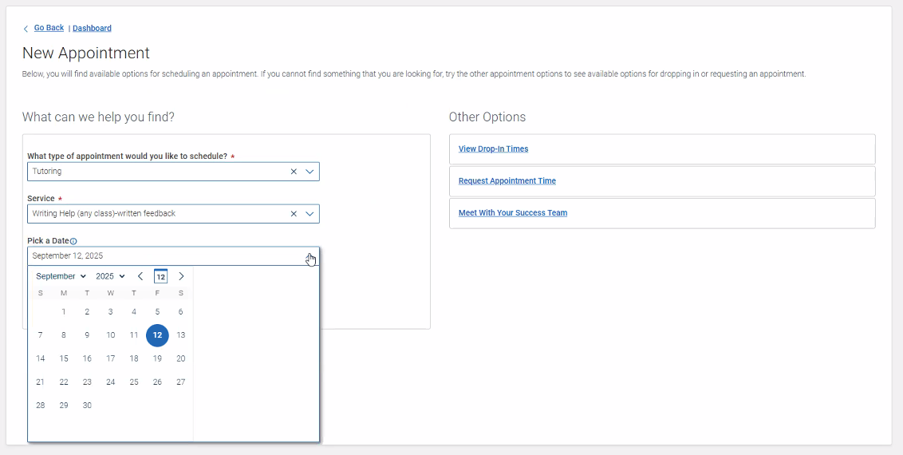

- Click “Find Available Time”

- Click your desired timeslot
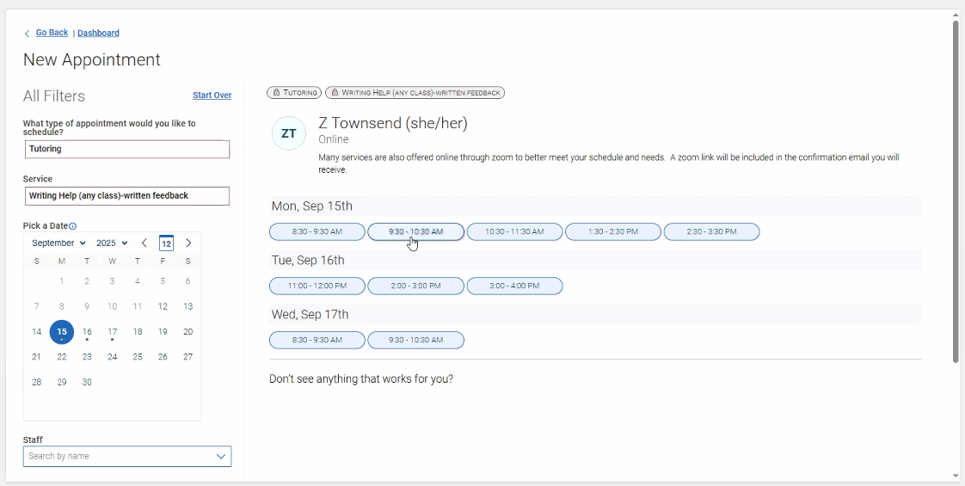

- Scroll to the “How would you like to meet?” dropdown list and select “Online-written feedback”
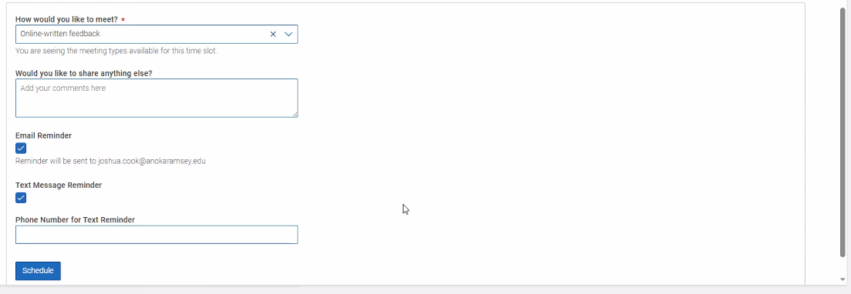

- Optional: enter phone number to receive a text message reminder

- Click “Schedule”
- Check your email for the questionnaire that must be completed before we can provide feedback. The sender will be the tutor’s name.
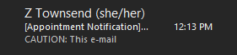

- In the email, click the “Answer Pre-Appointment Questions” hyperlink
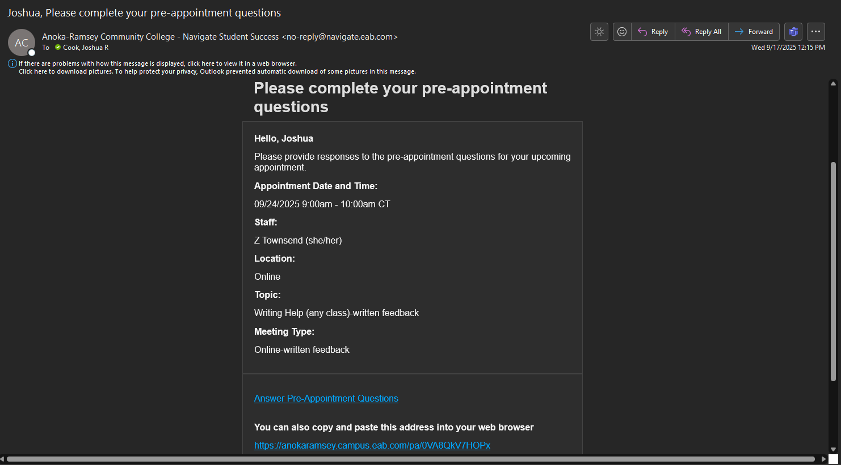

- Answer the Pre-Appointment Questions and upload document(s)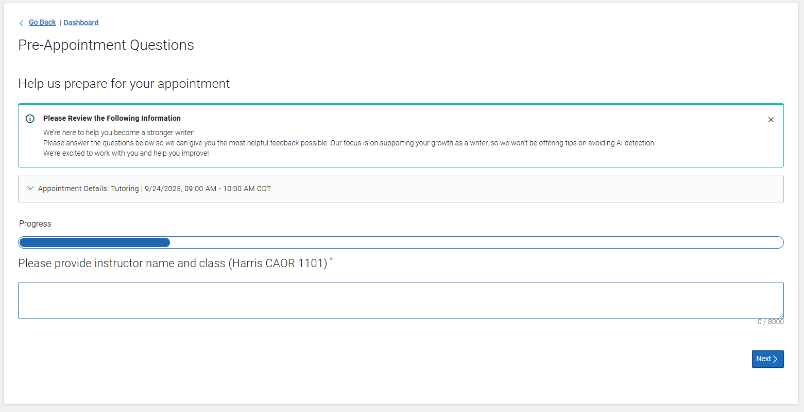

- Click “Submit”

- This screen confirms you have successfully submitted the questionnaire! Please allow up to 2 business days to receive feedback through your school email.
