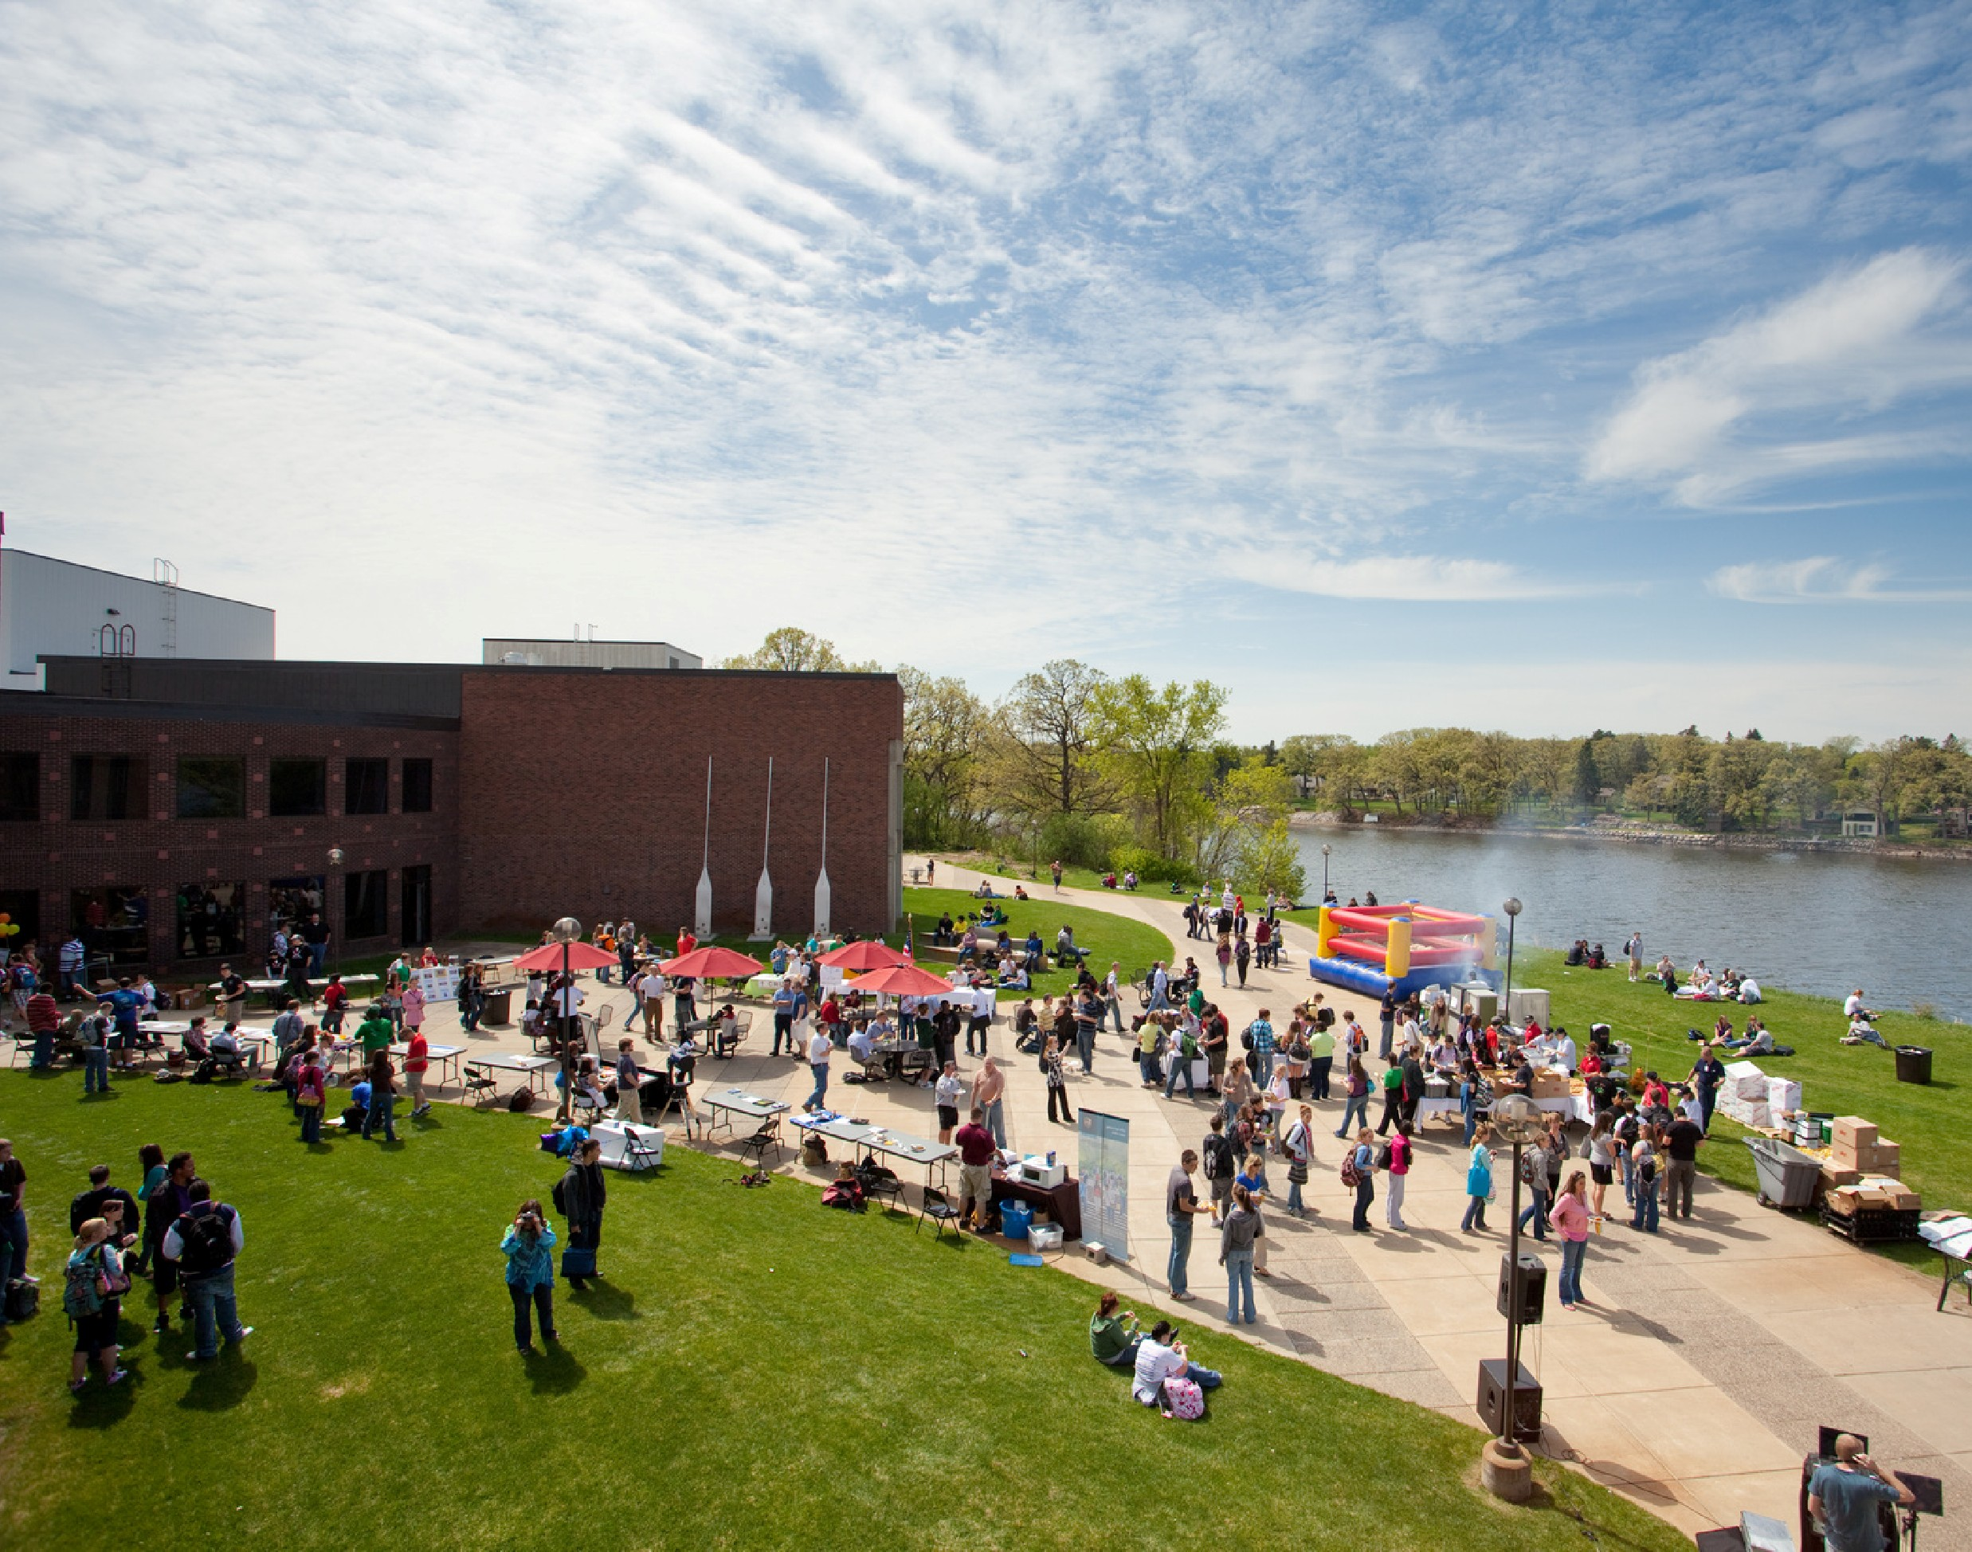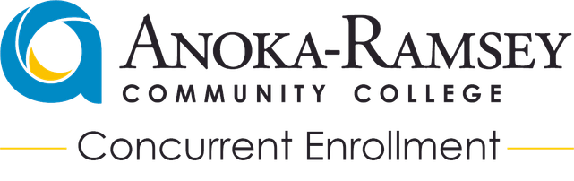
2026-2027
CONCURRENT ENROLLMENT
GUIDEBOOK

From The Anoka-Ramsey Concurrent Enrollment Team

Thank you for choosing Anoka-Ramsey Community College’s (ARCC) Concurrent Enrollment Program!
In this guide, you will find an introduction to ARCC’s Concurrent Enrollment Program, information about the roles and responsibilities of High School Partner Teachers and Faculty Liaisons, and pertinent policies, procedures, and practices of our Concurrent Enrollment Program. Many of these policies, procedures, and practices are mandated by the Minnesota Legislature, Minnesota State Colleges and Universities, and Anoka-Ramsey Community College.
All students in our Concurrent Enrollment Program are considered Anoka-Ramsey Community College students. Students are held to the same academic standards as on- campus students, and they have access to all of the student activities, academic resources, and professional staff that are a part of any college experience.
Please visit our Concurrent Enrollment page for general information and documentation for administrators, High School Partner Teachers and students: www.anokaramsey.edu/Concurrent

Concurrent Enrollment Program Contacts
Shannon Kirkeide - Dean of Academic and Community Outreach Program Development - new partnerships, programs, or courses
Instructional Support - primary contact for Faculty Liaisons and curriculum
Abbie Huttenburg - Director of Secondary Partnerships
Student Application/Registration contact
HS liaison - Primary contact for HS offices and HS partner teachers
Amie Bordwell - Concurrent Enrollment Transition Advisor
Academic Advisor in Concurrent Enrollment high schools
Student transcript/transfer - primary contact for students and counselors/deans
Reach out to Concurrent@anokaramsey.edu with any questions and we’ll put you in touch with the appropriate team member!

About Anoka-Ramsey Community College

Mission Statement
Anoka-Ramsey Community College is an open-door, comprehensive higher education institution committed to excellence in teaching and learning. Anoka-Ramsey is committed to responding to the educational needs of its changing communities and to providing opportunities for enhancing knowledge, skills, and values in a supportive learning environment.

School Profile
11,300 Students Enrolled Annually
High School Students make up over 40% of the enrollment at Anoka-Ramsey between both PSEO and Concurrent Enrollment students.
Accredited by the Higher Learning Commission (HLC) and the National Alliance for Concurrent Enrollment Partnerships (NACEP).

State Policies
According to Minnesota Statutes section 124D.09
(https://www.revisor.mn.gov/statutes/cite/124d.09) and Minnesota State Colleges and Universities Board Policy 3.5, a Post-Secondary Enrollment Options (PSEO) concurrent enrollment course is a college or university course made available through the PSEO program, offered through a high school, and taught by a high school teacher. Concurrent enrollment courses enroll only high school students who may earn both high school and college credit for satisfactorily completed courses. A PDF version of the Minnesota State policy 3.5 and Procedure 3.5.1 is available here: http://www.minnstate.edu/board/procedure/305p1.html
Anoka-Ramsey Community College’s Concurrent Enrollment Program works closely with partner high schools to determine course offerings, identify partner high school teachers credentialed to teach specific courses, and select students who meet the minimum requirements for participation. A high school may allow non-concurrent enrollment students to take concurrent enrollment courses for high school credit only, but a majority of the students (over 50%) in the course must be taking it for college credit. High Schools maintain the responsibility of ensuring that students who are not eligible are aware that they will not receive college credit.

Cost Structure
Anoka-Ramsey Community College charges partner high schools for each Concurrent Enrollment course offered at their institution.
Anoka-Ramsey Community College charges $3,000 per course, per mentor-mentee relationship, per term, regardless of the class size. ARCC aligns with the Minnesota State common pricing structure for all participating Minnesota State two-year colleges.

HIGH SCHOOL COORDINATION

The Anoka-Ramsey Concurrent Enrollment Program team relies on the strong partnerships with our high school administration, counselors/deans, and registration support. Every high school must designate one to two staff who will be responsible for communicating all student enrollment information along with any changes to planned courses or instructors.
Coordinators are responsible for knowing all student policies and for ensuring that all students submitted to ARCC on spreadsheets/rosters are meeting both the Program Eligibility and Course Pre-requisites.

High School Coordinator Responsibilities

Spring
- Coordinate High School Teacher Applications and new Course Request Forms - March 1st
- Submit Preliminary Course Information - April 15th
- Coordinate Student Applications to ARCC in partnership with ARCC CE team by June 15th
- Submit Final Course Information - June 15th
- Submit Student Spreadsheet and Transcripts - June 15th

Fall
- Review Summer Roster Edits from ARCC
  - Review rosters for any new students since June transcript/student list. Ensure that any new students complete applications and that transcripts have been submitted to ARCC.
- In Class Registration
  - Occurs in class with teachers.
  - Support any teacher/student with questions on eligibility.

Ongoing
- Communicate changes to courses as soon as possible.
  - Teacher changes, leaves of absence, or term/date changes should be communicated immediately.
- Coordinate submission of student withdrawals.
- Trimester 2, 3, and semester 2 starting courses will have adjusted application and registration deadlines. ARCC team will coordinate with high school based on their schedules.

Resources
Most documentation can be found on the Anoka-Ramsey Concurrent Enrollment Website including:
- High School Teacher Application
- New Course Request form
- Student Withdraw form

www.anokaramsey.edu/concurrent

HIGH SCHOOL PARTNER TEACHERS

High School Partner Teacher Credentialing
All instructors teaching an Anoka-Ramsey Concurrent Enrollment course are approved through an application process similar to what our on-campus faculty go through. Instructors in the program must meet the Higher Learning Commission's requirement of having the same minimum credentialing requirements of ARCC's on campus instructors. Specifics on the credentialing requirements for each field can be found on Minnesota State’s Faculty Credentialing website.

Any substitute teacher that will be in place for longer than 3 weeks must be approved by Anoka-Ramsey. Student teachers are not allowed to teach content in Anoka-Ramsey Concurrent Enrollment courses.
All new High School Partner Teachers (HSPTs) must submit an ARCC Concurrent Enrollment Teacher application along with copies of all transcripts and a resume to the Director of Secondary Partnerships. The application will be reviewed by the departmental Academic Dean, and applicants will be notified of their approval or denial. Following approval, HSPTs will be required to attend an Anoka-Ramsey programmatic orientation in addition to a course-specific orientation with their assigned ARCC Faculty Liaison.

Partner Teacher Expectations
High School Partner Teachers teaching in Anoka-Ramsey Community College’s Concurrent Enrollment Program are expected to offer students a rigorous, college level learning experience. HSPTs are expected to work closely with their assigned Faculty Liaison to ensure that students are being assessed at the same level as those students taking the same courses on an ARCC campus.
The Common Course Outline (CCO) is the guiding document that dictates what material is covered and to what depth this material is to be covered in a particular course. HSPTs are expected to use this document in conjunction with assistance from Faculty Liaisons to create a syllabus and course that covers all Learner Outcomes and Major Areas of Course Content. Failure to cover ALL Learner Outcomes and Major Areas of Course Content may jeopardize Anoka-Ramsey Community College’s ability to give participating students college credit.
Syllabi must be submitted to the Faculty Liaison for review prior to the course start as part of the preliminary visit. Anoka-Ramsey Faculty Liaisons work closely with HSPTs to determine appropriate expectations for Concurrent Enrollment courses, and all policies listed in the Concurrent Enrollment syllabus should be upheld by the school district.

Communication with ARCC
It is the expectation that HSPTs remain vigilant and timely in their communication with their Faculty Liaison and Anoka-Ramsey Community College Concurrent Enrollment Program Staff. Timely replies are essential when Faculty Liaisons are requesting information and/or attempting to set up classroom observations.

Course Assessments
High School Partner Teachers will be responsible for creating a paired assessment or using a department-wide common assessment, annually.
Towards the end of the course, High School Partner Teachers will be expected to administer an End of Course Evaluation to their students. This evaluation will assess course content and instruction. ARCC's CEP staff will provide teachers with the assessment tool in the final month of their course, and teachers are expected to set aside class time for students to complete the survey. Survey results are provided to instructors the following academic year.

High School Site Visits
Faculty Liaisons will conduct a Site Visit at least once during the course. For those High School Partner Teachers teaching a Concurrent Enrollment course for the first time, the Faculty Liaison will conduct at least two in-class observations.

HSPTs who have taught the Concurrent Enrollment Program course in the past may work with their Faculty Liaison on another option for the annual visit including grade-norming activities, Small Group Instructional Feedback (SGIF), assignments review or having the Faculty Liaison serve as a guest lecturer. In-class observations must be conducted at least once every three years for established partnerships.

Anoka-Ramsey Grading Policy and Practices
To support meaningful, beneficial partnerships that give students the opportunity to earn college credit while in high school, Anoka-Ramsey Community College’s High School Partners are responsible for adhering to the policies, procedures, and practices of Anoka-Ramsey. Failing to adhere jeopardizes Anoka-Ramsey Community College’s ability to offer Concurrent Enrollment Program classes and/or award college credit to students taking these courses. Adherence is critical.
It is expected that High School Administrators, Counselors/ Deans, and Teachers provide the same academic rigor in all Concurrent Enrollment (CE) Program courses as found in on-campus Anoka-Ramsey Community College courses. A clear grading policy for CE courses at the high school reinforces that students taking Concurrent Enrollment Program courses are graded and assessed at a level consistent with on-campus college courses. If the high school grade is shaded with a plus or minus, the Anoka-Ramsey grade will reflect the whole letter grade without the shading. Details on grading options can be found here: https://www.anokaramsey.edu/academics/classes-and-registration/grades.html
Opportunities where students can re-learn for mastery of content and learner outcomes are acceptable on a limited basis. High School Partner Teachers should consult with their Faculty Liaisons and the Dean of Academic and Community Outreach to determine appropriate college practices for re-learning material.
Anoka-Ramsey Community College’s Concurrent Enrollment Program’s grading policy is grounded in National Alliance for Concurrent Enrollment Partnerships (NACEP) Accreditation Standards. Students taking Anoka-Ramsey Community College Concurrent Enrollment Program courses are to be held to the same learning expectations and outcomes and assessed using similar methods as students in on-campus sections.

Addressing Non-Compliance
As part of being a part of ARCC’s Concurrent Enrollment Program, High School Partner Teachers agree to uphold the rigor of their classes to the same standards of those taught on our campuses. Along with teaching a rigorous, college-level course in the high school, High School Partner Teachers also agree to attend annual Professional Development Opportunities and remain vigilant in their communications with Anoka-Ramsey Community College representatives.
If a Faculty Liaison determines via correspondence or a site visit that the class being taught by a High School Partner Teacher does not meet the rigorous, college-level standards that are expected, the Faculty Liaison and Dean of Academic and Community Outreach will meet with the HSPT to discuss ways in which this issue can be addressed. Not meeting the standards is due cause for termination of the Concurrent Enrollment Program partnership.

If a High School Partner Teacher cannot attend the Professional Development hosted by Anoka-Ramsey Community College’s Concurrent Enrollment Program, it is the responsibility of the Partner Teacher to inform the Dean of Academic and Community Outreach of their absence. If continual absences become a problem, a meeting will be held to discuss the reason for these absences. On most occasions, High School Partner Teachers will consult with the Dean of Academic and Community Outreach, who oversees the Concurrent Enrollment Program, to determine what needs to be done to make up for the absence.
Anoka-Ramsey Community College’s Concurrent Enrollment Program reserves the right to de-certify, suspend, or dismiss any High School Partner Teacher at any time for gross misconduct or non-compliance with Anoka-Ramsey Community College policies and procedures. Please visit http://www.minnstate.edu/ board/procedure/1c0p1.html to access the Employee Code of Conduct.

STUDENT INFORMATION

Students taking Concurrent Enrollment Program courses at their high school are considered Anoka-Ramsey Community College students. Concurrent Enrollment Program students have the same level of access to learning resources and are held to the same rules, policies, and procedures as all other students. Thus, they are expected to follow all rules, policies, and procedures that pertain to Anoka-Ramsey Community College students. Similarly, students should be familiar with the policies listed in this guidebook.

The most relevant policies are covered here, but a full listing of the most current and complete official policies and procedures, is available at https://www.anokaramsey.edu/about/policies-disclosures/policies-procedures/index.html.

Concurrent Enrollment Program Eligibility
To participate in Anoka-Ramsey Community College’s Concurrent Enrollment Program, students must meet one of the Program Eligibility options and then meet the course placement (pre-requisite) requirement for the course they wish to register for. Anoka-Ramsey follows the Minn State Board Policy and Procedure for Program Eligibility. The eligibility options for Anoka-Ramsey's Concurrent Enrollment program are as follows:
- Seniors - Top half of class rank, or a 2.6 cum. unweighted GPA, or a standardized test score placing them at 50% nationally.
- Juniors - Top third of class rank, or a 2.6 cum, unweighted GPA, or a standardized test score placing them at 70% nationally.
- Sophomores - Top 10% of class rank, or a 3.0 cum. unweighted GPA, or a standardized test score placing them at 90% nationally. (10th grade enrollment is not available at all high schools or for all classes. Must be approved in advance by ARCC.)

Students who do not meet the above criteria may submit documentation other than that specified above of their readiness and ability to perform college-level work as determined by the college or university. Students should work with their Counselor/Dean if they want to appeal to participate in Concurrent Enrollment.
ARCC's Concurrent Enrollment Program expects that high schools verify that all students seeking college credit meet the program eligibility and course pre-requisites. Failing to adhere to eligibility requirements and/or registration policies and procedures may jeopardize Anoka-Ramsey Community College’s ability to offer Concurrent Enrollment Programs at institutions and/or award college credit to students enrolled in classes. Transcripts are required for all students enrolling in ARCC courses.

REGISTRATION PROCESSES AND POLICIES

Course Placement
All Anoka-Ramsey Concurrent Enrollment students must meet the specific course placement requirements (pre-requisite) for the courses they plan to take. All courses in the Concurrent Enrollment program require reading placements to enroll; however, there are some that may require additional Math or English placement levels. High Schools are responsible for ensuring that all students have met the placement/pre-requisite requirements of their registered courses.

Students can meet course placement requirements through assessments (Accuplacer/ACT/SAT/MCA) or high school GPA and coursework. Course placement requirements can be found on Anoka-Ramsey's website and are shared with schools annually.

Application Process
Students who wish to participate in ARCC’s Concurrent Enrollment Program initially register for their classes through their normal high school registration process. High school staff are expected to verify that students have
met both the program eligibility and any required prerequisites for the courses they plan to take.

Interested students are required to apply online to Anoka-Ramsey. High schools must conduct application sessions or provide application instructions to students in the spring of the year prior to the course start. Students who did not complete an application in the spring must complete an application by the end of the first week of the class, to be considered for admission.

High Schools are required to submit transcripts for every student taking concurrent enrollment courses. Students will not be admitted without an application and transcript on file with Anoka-Ramsey.
Anoka-Ramsey Concurrent Enrollment staff need sufficient time to review the student’s application and transcripts to verify eligibility, and course pre-requisites are met. Applications and transcripts are due by the end of the first week of the high school course.

Registration Process
During the second week of the high school course, the Anoka-Ramsey course will begin. Students will have the first 5 days of the Anoka-Ramsey course to add or drop their CE courses. Students will complete registration during their class time, under the direction of the high school instructor. High school instructors are supplied with directions, materials, and training to walk students through registration. High schools will have a final opportunity to correct rosters once student registration closes.

Add/Drop/Withdraw
ARCC Concurrent Enrollment students are bound by the same registration windows as all other ARCC students as follows:
- Add: Students may add a course through the 5th business day of the course.
- Drop: Students are allowed to drop any course through the 5th business day of the course. Dropped courses do not appear on a transcript and do not impact academic standing.
- Withdraw: Students are allowed to withdraw from a course through approx. 80% of the course. Withdraws appear on a transcript as a 'W" and have a direct impact on their academic standing.

Satisfactory Academic Progress (SAP)
Once a student enrolls in their 6th ARCC credit, they must meet minimum standards in order to continue to enroll in courses:
- 2.0 cumulative GPA in ARCC courses
- Complete 66.67% of attempted courses (Fs and Ws are not completed courses)
SAP is evaluated at the end of each year for Concurrent Enrollment students. The first time a student does not meet SAP, they are placed on Academic Warning. A student on Academic Warning who fails to meet the minimum standards a second time is then placed on Academic Suspension. Academic Suspension will follow a student and will impact their ability to register or receive Financial Aid at ARCC and other institutions after high school graduation!
Students earning D/F/Ws in ARCC courses should meet with their Counselor/Dean and our CE Transition Advisor to determine if taking more ARCC courses is appropriate. ARCC SAP Policy link

Student Code of Conduct
Every student at Anoka-Ramsey is expected to conduct themselves in accordance with Minn State Board Policy 3.6 and generally accepted norms of conduct to preserve Anoka-Ramsey’s safe and supportive learning environment. Anoka-Ramsey has the right to take action to support and protect the safety and well-being of the college community. Faculty has the responsibility to manage the classroom environment.
You can review the entire Student Code of Conduct here: www.anokaramsey.edu/about-us/policies-disclosures/policies-procedures/policy-3f1-studentconduct-code/
Plagiarism is serious. Plagiarism includes, but is not limited to, the use of paraphrase or direct quotation of the published or unpublished work of another person without full and clear acknowledgement, or the unacknowledged use of materials prepared by another person or agency engaged in the selling of term papers or other academic materials.

Parent Access to Information
Once a student enrolls in courses beyond the high school level (Concurrent Enrollment), the rights to educational records are transferred to the student alone per FERPA (Family Educational Rights and Privacy Act).
We cannot give out information to relatives or anyone else concerning a student's school record(s) without the student’s written, signed permission. However, we can collaborate with high schools and teachers regarding enrollment and grades each semester. View more information on FERPA, student data and who has access here:
www.anokaramsey.edu/about-us/policies-disclosures/policies-procedures/policy-2a1-datapractices/

Accommodations In ARCC Classrooms
A student enrolled in an Anoka-Ramsey college course may qualify for accommodations if they have a documented disability. Students will work with their high school teacher to access classroom accommodation based on guidance from the ARCC Office for Students with Disabilities.
More Information can be found on the OSD page here: https://www.anokaramsey.edu/support/office-for-students-with-disabilities

STUDENT RESOURCES, SERVICES & ACTIVITIES

All Concurrent Enrollment Program students have the same level of access to learning resources as students taking classes on our campuses. For a complete listing of student resources and schedules for these resources and services, please visit: www.anokaramsey.edu/resources
Technology Resources

StarID Information
Upon application to Anoka-Ramsey Community College, students are given a StarID and set up a password for their account. The StarID login information allows students to access their Anoka-Ramsey eServices account, library resources, email, and D2L Brightspace.

If a student loses their StarID information or needs to reset their password, they can do so at: starid.minnstate.edu.

eServices
eServices is a Minnesota State systemwide online registration and student information platform. In eServices, students can register for classes, update their personal contact information, track degree progress, view final grades, and obtain unofficial transcripts.

To log in, students use their StarID and Password. eServices can be accessed by selecting the Current Students option from the Information For section of the ARCC website.

ARCC Email
All Concurrent Enrollment students will have an ARCC school email assigned to them. Concurrent Enrollment Students are not required to use their ARCC email, but it can be used to stay connected to ARCC resources and events. Some ARCC services like on-campus tutoring may use the ARCC email as the communication method.

D2L Brightspace
D2L Brightspace is Anoka-Ramsey’s online learning platform. Here students can access online tutoring resources to assist them in their college courses. Students can log into D2L Brightspace with their Office 365 login (ARCC email and StarID password) from the Current Students dropdown on the Anoka-Ramsey homepage. Some ARCC high school teachers may use D2L for their entire course or just a few assignments.

Photo ID
All Concurrent Enrollment students are eligible to receive an Anoka-Ramsey Photo ID. Students can complete a Photo ID request online here: Photo ID Request Form

The ARCC ID will give students access to the Health and Wellness Centers, library, sporting events, various on-campus programming and discounts at participating local businesses.

Advising Resources

Academic Advising
Anoka-Ramsey Academic Advisors assist students with a variety of things like scheduling, degree/educational requirements, transfer planning and other questions/concerns about a student's current or potential Concurrent Enrollment courses.

The Concurrent Enrollment program is fortunate to have an Academic Advisor who works ONLY with Concurrent Enrollment students. Amie partners with our high school counselors and deans to make sure that students are getting accurate information about their classes so that students can make informed decisions about which courses to select and how different decisions may impact their academic standing.

Reach out to your ARCC advisor, Amie Bordwell at amie.bordwell@anokaramsey.edu or concurrent@anokaramsey.edu

Transfer Planning and Resources
In addition to tapping into our Academic Advisor, there are some resources that can help students before, during, and after their time as a Concurrent Enrollment student.

Transferology
Making a FREE account at transferology.com offers students the ability to see how their credits might transfer to local, regional and national colleges and universities.
If a school isn't listed, there is often transfer information listed on the college/university's website.

Sending ARCC Transcripts
Once students have completed their ARCC courses, they should request to have their transcript set on to the college or university they plan on attending.
Minnesota State (Minn State) Schools:
Most Minnesota State schools can simply pull in a transcript from Anoka-Ramsey at no cost. Encourage students to talk to the Minnesota State school directly for their process. (public, non-UMN schools)

Private, Out-of-State, and University of Minnesota:
Students will need to request an official ARCC transcript through Parchment.com. There is typically a small fee per transcript.

Additional Services and Activities

Office For Students with Disabilities
As referenced earlier, our OSD team provides support and guidance to CE high school teachers working with students with documented disabilities. disabilityservices@anokaramsey.edu 763.433.1350

Library Services
Anoka-Ramsey's library provides on-campus and online access to numerous academic databases, catalogs, journals, and books. Students can borrow books from our library or simply access online resources.
If you aren't sure what resources are best for your needs, reach out to one of our friendly librarians for assistance!
arcc.library@anokaramsey.edu www.anokaramsey.edu/library

Academic Support Centers - Tutoring
The Academic Support Centers (ASC) provide peer and professional tutoring to students. Tutoring is available in a variety of subjects, at differing times of the day, through both online and on-campus methods. Students can utilize ARCC tutors through zoom or use the tutor.com service in the D2L Brightspace platform. This is an essential and FREE resource for students. www.anokaramsey.edu/resources/tutoring-services

Student Life Programming
Our Student Life office organizes a variety of events to engage and support Anoka-Ramsey students. You are welcome to join us for any events, engaging speakers, cultural awareness events, and other events that are held at either of our campuses! Visit our Student Life page, to learn about the varied opportunities for engagement at Anoka-Ramsey! www.anokaramsey.edu/campus-life/

Health And Wellness Centers
Students can access our beautiful fitness centers, walking track, practice gym open hours, intramural/recreational sports, and a variety of wellness courses offered to Anoka-Ramsey students – at no charge, with their ARCC photo ID! For more details and hours: www.anokaramsey.edu/campus-life/healthwellness/

Fine Arts Events
We have vibrant Music and Theatre departments at Anoka-Ramsey, which produce concerts, plays and musicals for our students and community. Anoka-Ramsey students can get two free tickets to any production! Many events and concerts on campus are free and open to the public, so we encourage you to view our Student Life schedule and plan a visit.

All Resources & Student Life Activities Are Free!

QUESTIONS?
Reach out to any member of our team or send a question to:

Concurrent@anokaramsey.edu
Anoka-Ramsey Community College www.anokaramsey.edu
Cambridge Campus
300 Spirit River Dr S
Cambridge, MN 55008
Coon Rapids Campus
11200 Mississippi BLVD NW
Coon Rapids, MN 55433

